OPAL Workshop  June 26-27, 2009
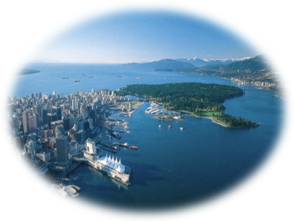
1st International Workshop on Dynamic Modeling of Oral, Pharyngeal and Laryngeal Complex
for Biomedical Applications
University of British Columbia, Vancouver, Canada

REGISTRATION FORM
Please fill in the appropriate details, then email to lavana@magic.ubc.ca or fax 1-604-822-8989

Name:
Title/Position:
Organization:
Address:
City: |  | Province: |  | Country:
Email: |  | 2nd Email:
Business Phone: |  | Cellular Phone:
Flight Details: | Total Cost $ | Arrival Date/Time: | Departure Date/Time:
Accommodation: | ☐ Thursday June 25 ☐ Friday June 26 ☐ Saturday June 27 |  | Additional nights:
On site accommodation is available at University of BC. Arrangements have been made for out of town guests to stay at UBC Marine Drive Residence for 3 nights paid by the workshop: Thursday, June 25, Friday, June 26 & Saturday, June 27. Private bedroom with single bed, telephone and clock radio, in a four-bedroom shared apartment. (Separate bedrooms with lock) Guests share two washrooms, lounge area and kitchen. Accommodations must be made by May 31, 2009 to qualify for special rates.  We have arranged a special group rate of $49.00/night if you are in a quad shared accommodations; this rate only applies if 4 individuals are sharing. For single room the special rate is $99.00/night. If you require additional nights please indicate on this form. If we cannot get 4 individuals in a quad suite we will need to book you into a single bedroom the special rate is $99.00/night. We will arrange the booking for the extra nights as well, however, you will be responsible for the additional charges. |  |  | 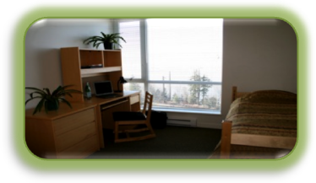

ADDITIONAL NEEDS: If you have any special dietary needs or any disabilities for which assistance is likely to needed please advise the organizers of your requirements when registering.

TRANSPORTATION: We recommend for you to get a taxi to transport you to UBC campus.

CONTACT REGISTRATION:
Attention: Lavana Lea - OPAL Workshop Registrations,
University of British Columbia Forestry Sciences Bldg, 3640 - 2424 Main Mall, Vancouver, BC, V6T 1Z4, Canada
Telephone: 1+(604) 822-8990 | Fax: 1+(604) 822-8989 | Email: lavana@magic.ubc.ca
Web: http://www.magic.ubc.ca/artisynth/pmwiki.php?n=OPAL.Workshop2009

